**Practical 7**

**Aim**: Perform all the SQL join queries

Q ) Create 2 tables, Customer Table with the following attributes (C_ID,C_NAME,ADDR) and Orders table with the following attributes (O_ID,O_NAME,C_ID) and perform the following joins :

1)Inner Joins

2)Left Joins

3)Right Joins

4)Left Joins(where B.Key is NULL)

5)Right Joins(Where A.key is NULL)

6)Full Outer Join

7)Full Outer Join( Where A.Key is NULL or B.Key is NULL)

**Answers:**

**Step1:** **Create tables Customer and Orders along with their attributes**

CREATE TABLE CUSTOMER(C_ID NUMBER(20) PRIMARY KEY, C_NAME VARCHAR(50) NOT NULL, ADDR VARCHAR(100) NOT NULL);

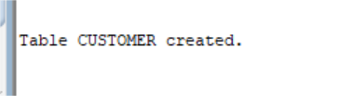

INSERT INTO CUSTOMER VALUES(123,'Deivangh','tadgusw');

INSERT INTO CUSTOMER VALUES(345,'Aditya','ewjnrvyt');

INSERT INTO CUSTOMER VALUES(567,'Himanshu','jqzjeo');

INSERT INTO CUSTOMER VALUES(789,'Jeetika','nskfw');

INSERT INTO CUSTOMER VALUES(981,'Hitesh','fjjwd');

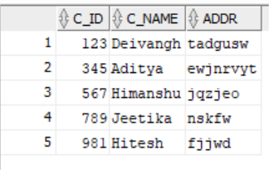

CREATE TABLE ORDERS(O_ID NUMBER(20) PRIMARY KEY , O_NAME VARCHAR(50) NOT NULL,C_ID NUMBER(20), FOREIGN KEY(C_ID) REFERENCES CUSTOMER(C_ID));

INSERT INTO ORDERS VALUES(112,'Toy',123);

INSERT INTO ORDERS VALUES(187,'Kitty',345);

INSERT INTO ORDERS VALUES(200,'Plates',789);

**Step2: Perform the queries on joins :**

1)Inner Joins:

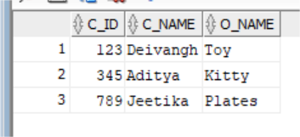SELECT A.C_ID,A.C_NAME,B.O_NAME FROM CUSTOMER A INNER JOIN ORDERS B ON A.C_ID=B.C_ID;

2)Left Joins:

SELECT A.C_ID,A.C_NAME,B.O_NAME FROM CUSTOMER A LEFT JOIN ORDERS B ON A.C_ID=B.C_ID;

3)Right Joins:

SELECT A.C_ID,A.C_NAME,B.O_NAME FROM CUSTOMER A RIGHT JOIN ORDERS B ON A.C_ID=B.C_ID;

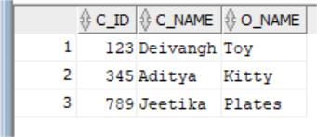

4) Left Joins(where B.Key is NULL):

SELECT A.C_ID,A.C_NAME,B.O_NAME FROM CUSTOMER A LEFT JOIN ORDERS B ON A.C_ID=B.C_ID WHERE B.C_ID IS NULL;

5) Right Joins(Where A.key is NULL):

SELECT A.C_ID,A.C_NAME,B.O_NAME FROM CUSTOMER A RIGHT JOIN ORDERS B ON A.C_ID=B.C_ID WHERE A.C_ID IS NULL;

6) Full Outer Join:

SELECT A.C_ID,A.C_NAME,B.O_NAME FROM CUSTOMER A FULL OUTER JOIN ORDERS B ON A.C_ID=B.C_ID;

7) Full Outer Join( Where A.Key is NULL or B.Key is NULL):

SELECT A.C_ID,A.C_NAME,B.O_NAME FROM CUSTOMER A FULL OUTER JOIN ORDERS B ON A.C_ID=B.C_ID WHERE A.C_ID IS NULL OR B.C_ID IS NULL;

